**Hands on 1**

**Create a Spring Web Project using Maven**

**Program:**

**pom.xml**

<?xml version="1.0" encoding="UTF-8"?>

<project xmlns="http://maven.apache.org/POM/4.0.0" xmlns:xsi="http://www.w3.org/2001/XMLSchema-instance"

xsi:schemaLocation="http://maven.apache.org/POM/4.0.0 https://maven.apache.org/xsd/maven-4.0.0.xsd">

<modelVersion>4.0.0</modelVersion>

<parent>

<groupId>org.springframework.boot</groupId>

<artifactId>spring-boot-starter-parent</artifactId>

<version>3.5.3</version>

<relativePath/> <!-- lookup parent from repository -->

</parent>

<groupId>com.cognizant</groupId>

<artifactId>spring-learn</artifactId>

<version>0.0.1-SNAPSHOT</version>

<name>spring-learn</name>

<description>Demo project for Spring Boot</description>

<url/>

<licenses>

<license/>

</licenses>

<developers>

<developer/>

</developers>

<scm>

<connection/>

<developerConnection/>

<tag/>

<url/>

</scm>

<properties>

<java.version>17</java.version>

</properties>

<dependencies>

<dependency>

<groupId>org.springframework.boot</groupId>

<artifactId>spring-boot-starter-web</artifactId>

</dependency>

<dependency>

<groupId>org.springframework.boot</groupId>

<artifactId>spring-boot-devtools</artifactId>

<scope>runtime</scope>

<optional>true</optional>

</dependency>

<dependency>

<groupId>org.springframework.boot</groupId>

<artifactId>spring-boot-starter-test</artifactId>

<scope>test</scope>

</dependency>

</dependencies>

<build>

<plugins>

<plugin>

<groupId>org.springframework.boot</groupId>

<artifactId>spring-boot-maven-plugin</artifactId>

</plugin>

</plugins>

</build>

</project>

**SpringLearnApplication.java**

package com.cognizant.spring_learn;

import org.springframework.boot.SpringApplication;

import org.springframework.boot.autoconfigure.SpringBootApplication;

import org.slf4j.Logger;

import org.slf4j.LoggerFactory;

@SpringBootApplication

public class SpringLearnApplication {

private static final Logger *LOGGER*=LoggerFactory.*getLogger*(SpringLearnApplication.class);

public static void main(String[] args) {

SpringApplication.*run*(SpringLearnApplication.class, args);

*LOGGER*.info("Application Started Successfully");

}

}

**SpringLearnApplicationTests.java**

package com.cognizant.spring_learn;

import org.junit.jupiter.api.Test;

import org.springframework.boot.test.context.SpringBootTest;

@SpringBootTest

class SpringLearnApplicationTests {

@Test

void contextLoads() {

}

}

**Output:**

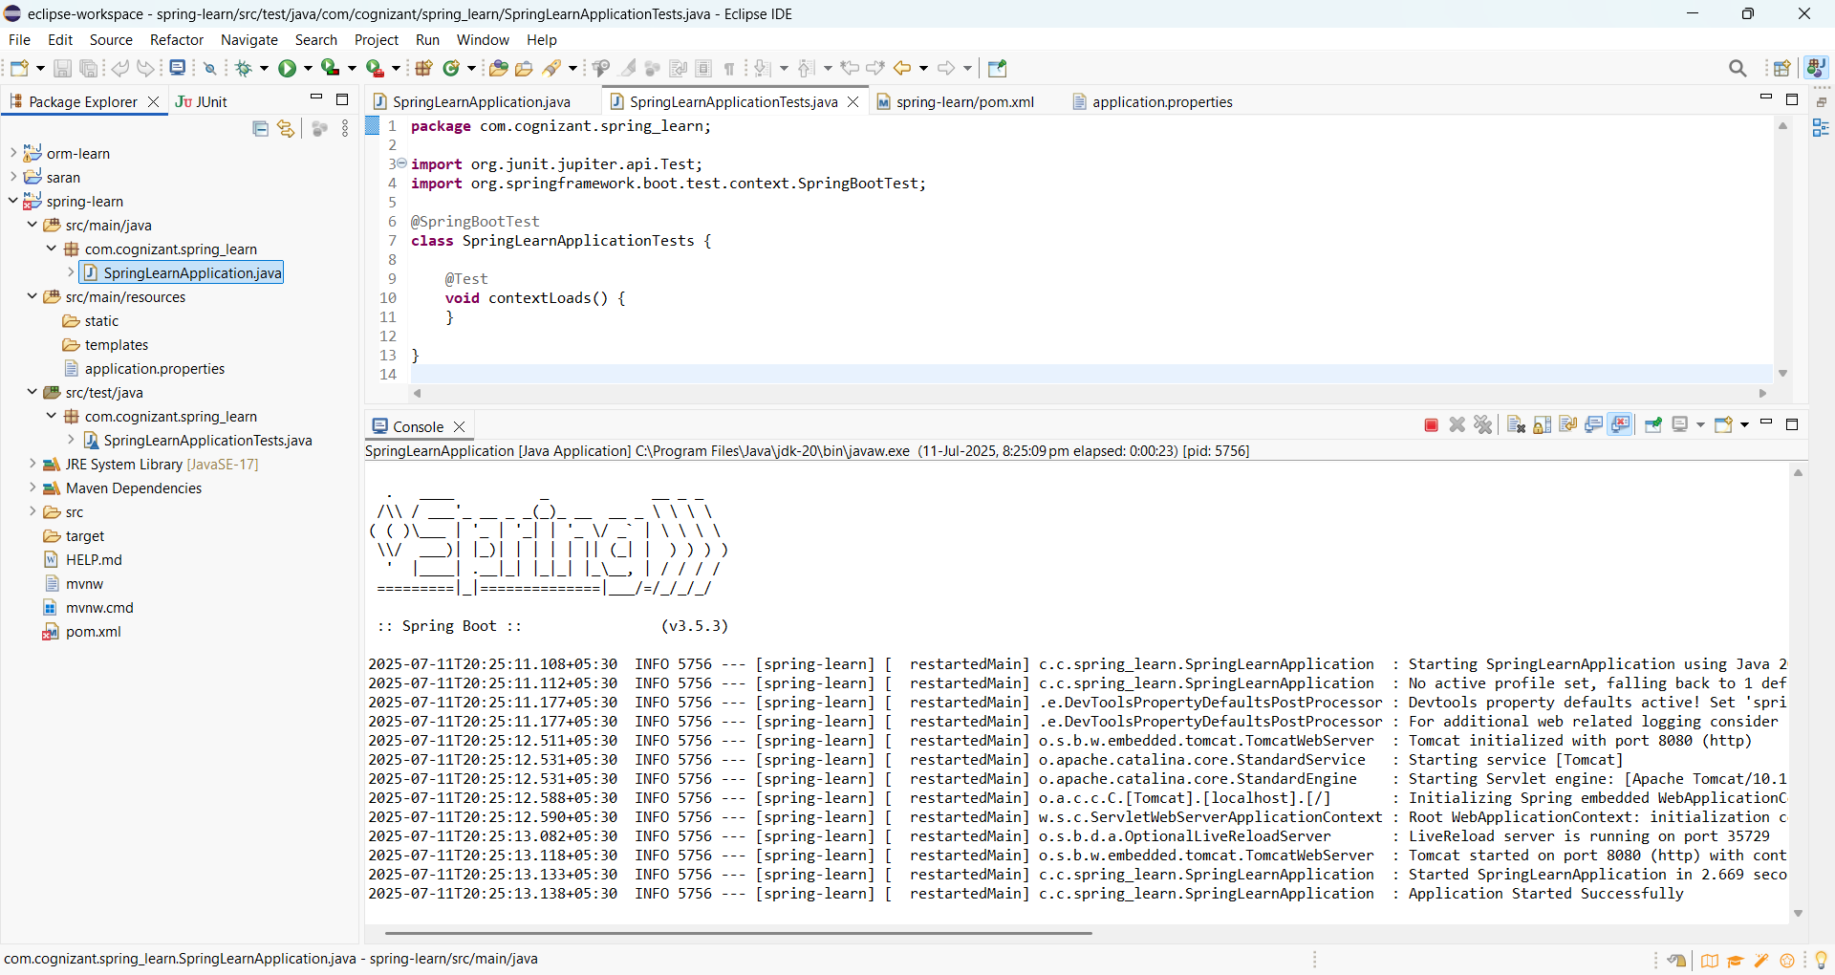

**Hands on 2**

**Spring Core – Load SimpleDateFormat from Spring Configuration XML**   
  
SimpleDateFormat with the pattern ‘dd/MM/yyyy’ is created in multiple places of an application. To avoid creation of SimpleDateFormat in multiple places, define a bean in Spring XML Configuration file and retrieve the date.  
  
**Program:**

**pom.xml**

<?xml version="1.0" encoding="UTF-8"?>

<project xmlns="http://maven.apache.org/POM/4.0.0" xmlns:xsi="http://www.w3.org/2001/XMLSchema-instance"

xsi:schemaLocation="http://maven.apache.org/POM/4.0.0 https://maven.apache.org/xsd/maven-4.0.0.xsd">

<modelVersion>4.0.0</modelVersion>

<parent>

<groupId>org.springframework.boot</groupId>

<artifactId>spring-boot-starter-parent</artifactId>

<version>3.5.3</version>

<relativePath/> <!-- lookup parent from repository -->

</parent>

<groupId>com.cognizant</groupId>

<artifactId>spring-learn</artifactId>

<version>0.0.1-SNAPSHOT</version>

<name>spring-learn</name>

<description>Demo project for Spring Boot</description>

<url/>

<licenses>

<license/>

</licenses>

<developers>

<developer/>

</developers>

<scm>

<connection/>

<developerConnection/>

<tag/>

<url/>

</scm>

<properties>

<java.version>17</java.version>

</properties>

<dependencies>

<dependency>

<groupId>org.springframework.boot</groupId>

<artifactId>spring-boot-starter-web</artifactId>

</dependency>

<dependency>

<groupId>org.springframework.boot</groupId>

<artifactId>spring-boot-devtools</artifactId>

<scope>runtime</scope>

<optional>true</optional>

</dependency>

<dependency>

<groupId>org.springframework.boot</groupId>

<artifactId>spring-boot-starter-test</artifactId>

<scope>test</scope>

</dependency>

</dependencies>

<build>

<plugins>

<plugin>

<groupId>org.springframework.boot</groupId>

<artifactId>spring-boot-maven-plugin</artifactId>

</plugin>

</plugins>

</build>

</project>

**date-format.xml**

<?xml version="1.0" encoding="UTF-8"?>

<beans xmlns="http://www.springframework.org/schema/beans"

xmlns:xsi="http://www.w3.org/2001/XMLSchema-instance"

xsi:schemaLocation="http://www.springframework.org/schema/beans

https://www.springframework.org/schema/beans/spring-beans.xsd">

<bean id="dateFormat" class="java.text.SimpleDateFormat">

<constructor-arg value="dd/MM/yyyy" />

</bean>

</beans>

**SpringLearnApplication.java**

package com.cognizant.spring_learn;

import java.text.SimpleDateFormat;

import java.util.Date;

import org.springframework.context.ApplicationContext;

import org.springframework.context.support.ClassPathXmlApplicationContext;

public class SpringLearnApplication {

public static void displayDate() throws Exception {

// Load Spring XML Configuration

ApplicationContext context = new ClassPathXmlApplicationContext("date-format.xml");

// Get the dateFormat bean

SimpleDateFormat format = context.getBean("dateFormat", SimpleDateFormat.class);

// Parse date string

Date date = format.parse("31/12/2018");

// Print date

System.*out*.println("Parsed Date: " + date);

}

public static void main(String[] args) throws Exception {

*displayDate*();

}

}

**Output:**

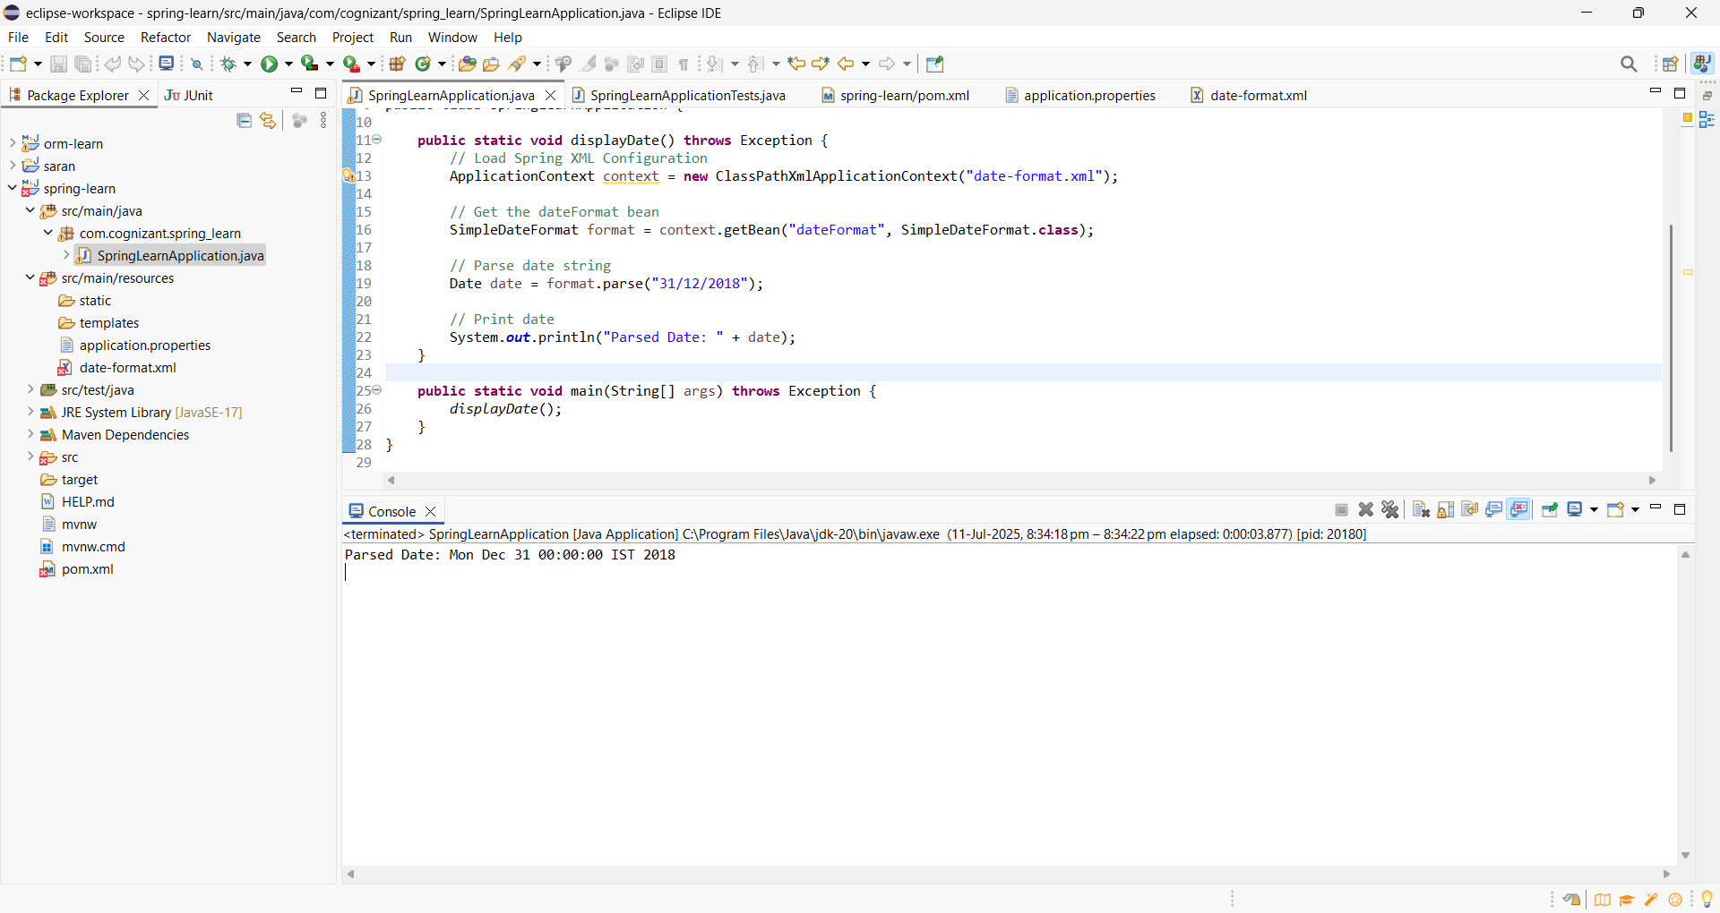

**Hands on 3**

**Spring Core - Incorporate Logging**   
  
Incorporate logging in the Spring Boot project created in previous hands on.

**Program:**

**pom.xml**

<?xml version="1.0" encoding="UTF-8"?>

<project xmlns="http://maven.apache.org/POM/4.0.0" xmlns:xsi="http://www.w3.org/2001/XMLSchema-instance"

xsi:schemaLocation="http://maven.apache.org/POM/4.0.0 https://maven.apache.org/xsd/maven-4.0.0.xsd">

<modelVersion>4.0.0</modelVersion>

<parent>

<groupId>org.springframework.boot</groupId>

<artifactId>spring-boot-starter-parent</artifactId>

<version>3.5.3</version>

<relativePath/> <!-- lookup parent from repository -->

</parent>

<groupId>com.cognizant</groupId>

<artifactId>spring-learn</artifactId>

<version>0.0.1-SNAPSHOT</version>

<name>spring-learn</name>

<description>Demo project for Spring Boot</description>

<url/>

<licenses>

<license/>

</licenses>

<developers>

<developer/>

</developers>

<scm>

<connection/>

<developerConnection/>

<tag/>

<url/>

</scm>

<properties>

<java.version>17</java.version>

</properties>

<dependencies>

<dependency>

<groupId>org.springframework.boot</groupId>

<artifactId>spring-boot-starter-web</artifactId>

</dependency>

<dependency>

<groupId>org.springframework.boot</groupId>

<artifactId>spring-boot-devtools</artifactId>

<scope>runtime</scope>

<optional>true</optional>

</dependency>

<dependency>

<groupId>org.springframework.boot</groupId>

<artifactId>spring-boot-starter-test</artifactId>

<scope>test</scope>

</dependency>

<dependency>

<groupId>org.springframework</groupId>

<artifactId>spring-context</artifactId>

<version>5.3.33</version>

</dependency>

<dependency>

<groupId>org.slf4j</groupId>

<artifactId>slf4j-api</artifactId>

</dependency>

<dependency>

<groupId>ch.qos.logback</groupId>

<artifactId>logback-classic</artifactId>

</dependency>

</dependencies>

<build>

<plugins>

<plugin>

<groupId>org.springframework.boot</groupId>

<artifactId>spring-boot-maven-plugin</artifactId>

</plugin>

</plugins>

</build>

</project>

**application.properties**

spring.application.name=spring-learn

logging.level.org.springframework=info

logging.level.com.cognizant.spring_learn=debug

logging.pattern.console=%d{yyMMdd}|%d{HH:mm:ss.SSS}|%-20.20thread|%5p|%-25.25logger{25}|%25M|%m%n

**date-format.xml**

<?xml version="1.0" encoding="UTF-8"?>

<beans xmlns="http://www.springframework.org/schema/beans"

xmlns:xsi="http://www.w3.org/2001/XMLSchema-instance"

xsi:schemaLocation="http://www.springframework.org/schema/beans

https://www.springframework.org/schema/beans/spring-beans.xsd">

<bean id="dateFormat" class="java.text.SimpleDateFormat">

<constructor-arg value="dd/MM/yyyy" />

</bean>

</beans>

**SpringLearnApplication.java**

package com.cognizant.spring_learn;

import java.text.SimpleDateFormat;

import java.util.Date;

import org.slf4j.Logger;

import org.slf4j.LoggerFactory;

import org.springframework.context.ApplicationContext;

import org.springframework.context.support.ClassPathXmlApplicationContext;

public class SpringLearnApplication {

// Logger declaration

private static final Logger *LOGGER* = LoggerFactory.*getLogger*(SpringLearnApplication.class);

public static void displayDate() throws Exception {

*LOGGER*.info("START");

// Load Spring XML configuration

ApplicationContext context = new ClassPathXmlApplicationContext("date-format.xml");

// Get the dateFormat bean

SimpleDateFormat format = context.getBean("dateFormat", SimpleDateFormat.class);

// Parse the date

Date date = format.parse("31/12/2018");

// Log the parsed date

*LOGGER*.debug("Parsed Date: {}", date);

*LOGGER*.info("END");

}

public static void main(String[] args) throws Exception {

*displayDate*();

}

}

**Output:**

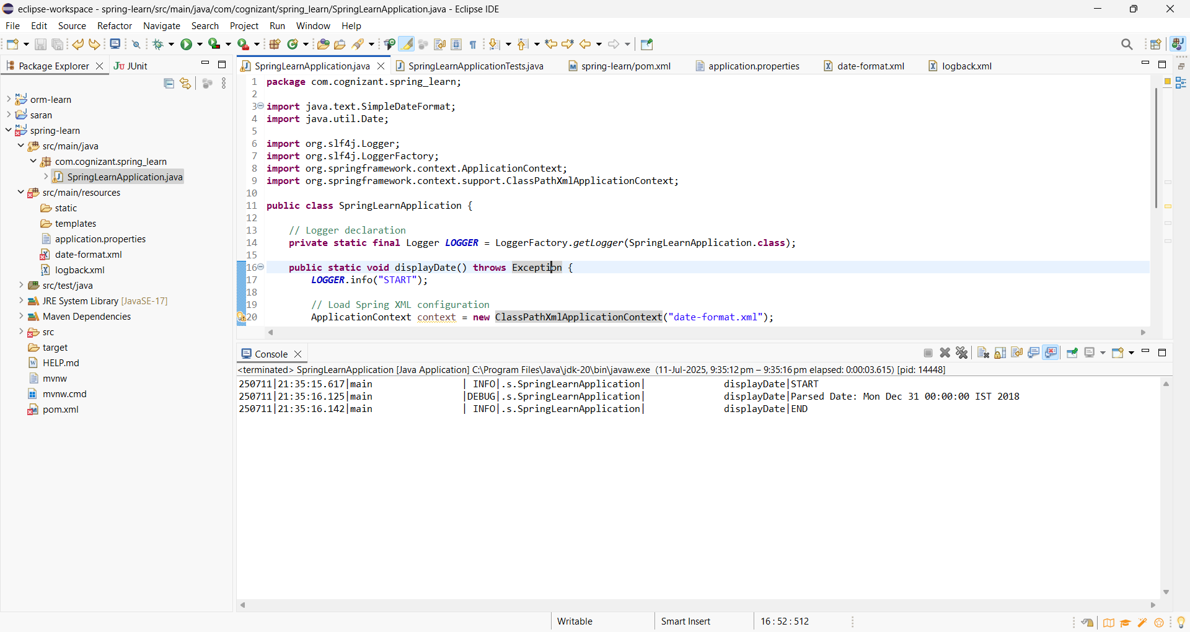

**Hands on 4**

**Spring Core – Load Country from Spring Configuration XML**An airlines website is going to support booking on four countries. There will be a drop down on the home page of this website to select the respective country. It is also important to store the two-character ISO code of each country. 

|  |  |
| --- | --- |
| **Code** | **Name** |
| US | United States |
| DE | Germany |
| IN | India |
| JP | Japan |

Above data has to be stored in spring configuration file. Write a program to read this configuration file and display the details.

**Program:**

**pom.xml**

<?xml version="1.0" encoding="UTF-8"?>

<project xmlns="http://maven.apache.org/POM/4.0.0" xmlns:xsi="http://www.w3.org/2001/XMLSchema-instance"

xsi:schemaLocation="http://maven.apache.org/POM/4.0.0 https://maven.apache.org/xsd/maven-4.0.0.xsd">

<modelVersion>4.0.0</modelVersion>

<parent>

<groupId>org.springframework.boot</groupId>

<artifactId>spring-boot-starter-parent</artifactId>

<version>3.5.3</version>

<relativePath/> <!-- lookup parent from repository -->

</parent>

<groupId>com.cognizant</groupId>

<artifactId>spring-learn</artifactId>

<version>0.0.1-SNAPSHOT</version>

<name>spring-learn</name>

<description>Demo project for Spring Boot</description>

<url/>

<licenses>

<license/>

</licenses>

<developers>

<developer/>

</developers>

<scm>

<connection/>

<developerConnection/>

<tag/>

<url/>

</scm>

<properties>

<java.version>17</java.version>

</properties>

<dependencies>

<dependency>

<groupId>org.springframework.boot</groupId>

<artifactId>spring-boot-starter-web</artifactId>

</dependency>

<dependency>

<groupId>org.springframework.boot</groupId>

<artifactId>spring-boot-devtools</artifactId>

<scope>runtime</scope>

<optional>true</optional>

</dependency>

<dependency>

<groupId>org.springframework.boot</groupId>

<artifactId>spring-boot-starter-test</artifactId>

<scope>test</scope>

</dependency>

<dependency>

<groupId>org.springframework</groupId>

<artifactId>spring-context</artifactId>

<version>5.3.33</version>

</dependency>

<dependency>

<groupId>org.slf4j</groupId>

<artifactId>slf4j-api</artifactId>

</dependency>

<dependency>

<groupId>ch.qos.logback</groupId>

<artifactId>logback-classic</artifactId>

</dependency>

</dependencies>

<build>

<plugins>

<plugin>

<groupId>org.springframework.boot</groupId>

<artifactId>spring-boot-maven-plugin</artifactId>

</plugin>

</plugins>

</build>

</project>

**Country.java**

package com.cognizant.spring_learn;

import org.slf4j.Logger;

import org.slf4j.LoggerFactory;

public class Country {

private static final Logger *LOGGER* = LoggerFactory.*getLogger*(Country.class);

private String code;

private String name;

// No-arg constructor

public Country() {

*LOGGER*.debug("Inside Country Constructor.");

}

public String getCode() {

*LOGGER*.debug("Getting code: {}", code);

return code;

}

public void setCode(String code) {

*LOGGER*.debug("Setting code: {}", code);

this.code = code;

}

public String getName() {

*LOGGER*.debug("Getting name: {}", name);

return name;

}

public void setName(String name) {

*LOGGER*.debug("Setting name: {}", name);

this.name = name;

}

@Override

public String toString() {

return "Country [code=" + code + ", name=" + name + "]";

}

}

**application.properties**

spring.application.name=spring-learn

logging.level.org.springframework=info

logging.level.com.cognizant.spring_learn=debug

logging.pattern.console=%d{yyMMdd}|%d{HH:mm:ss.SSS}|%-20.20thread|%5p|%-25.25logger{25}|%25M|%m%n

**country.xml**

<?xml version="1.0" encoding="UTF-8"?>

<beans xmlns="http://www.springframework.org/schema/beans"

xmlns:xsi="http://www.w3.org/2001/XMLSchema-instance"

xsi:schemaLocation="http://www.springframework.org/schema/beans

https://www.springframework.org/schema/beans/spring-beans.xsd">

<bean id="country" class="com.cognizant.spring_learn.Country">

<property name="code" value="IN" />

<property name="name" value="India" />

</bean>

</beans>

**Output:**

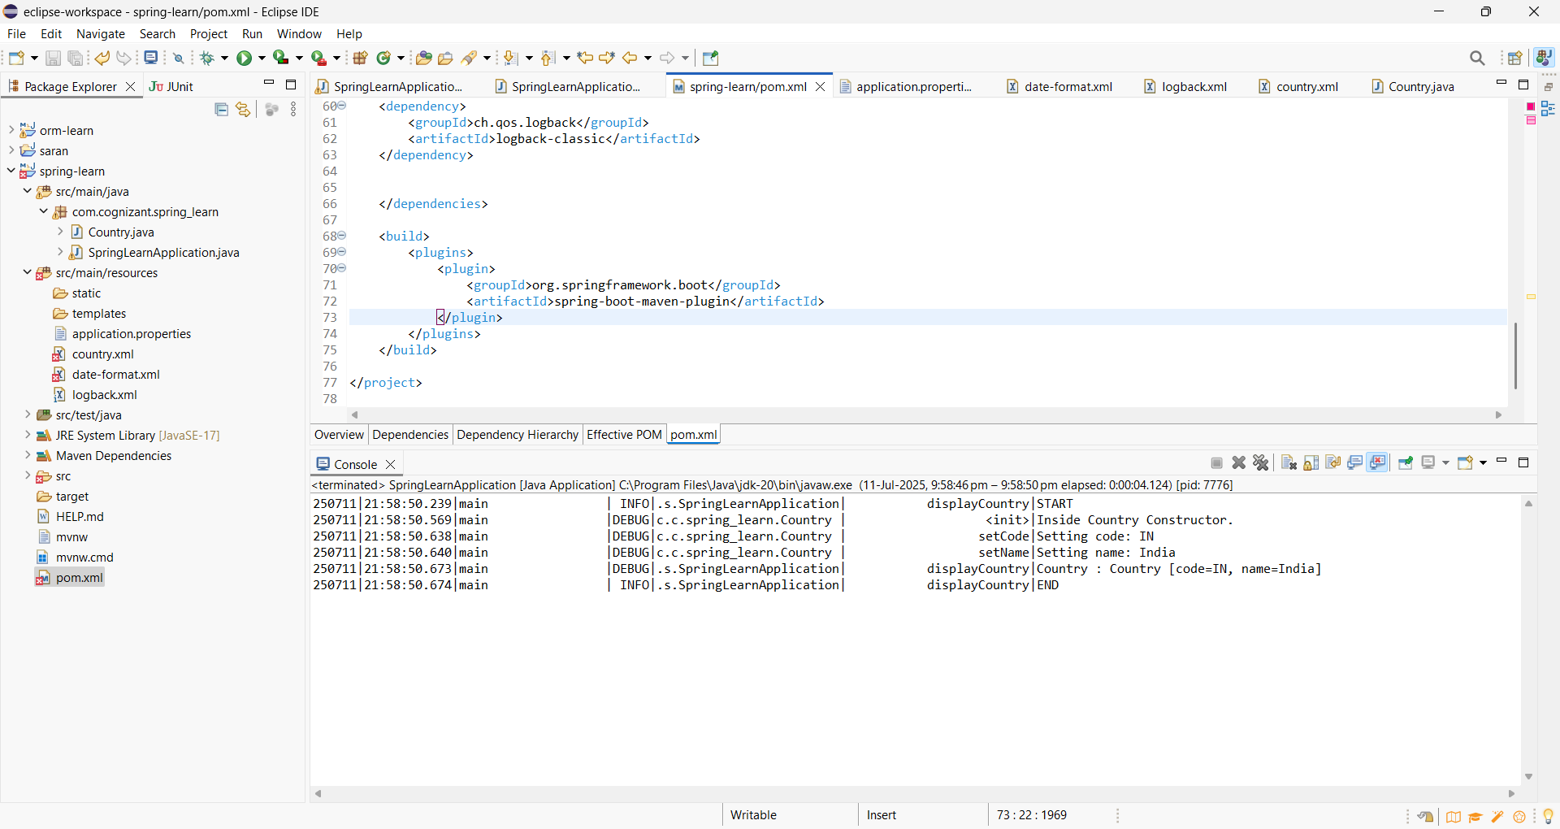

**Hands on 5**

**Spring Core – Demonstration of Singleton Scope and Prototype Scope**The Country bean done in the previous hands on will be used to demonstrate the scopes in Spring.

**Program:**

**country.xml**

<?xml version="1.0" encoding="UTF-8"?>

<beans xmlns="http://www.springframework.org/schema/beans"

xmlns:xsi="http://www.w3.org/2001/XMLSchema-instance"

xsi:schemaLocation="http://www.springframework.org/schema/beans

https://www.springframework.org/schema/beans/spring-beans.xsd">

<bean id="country" class="com.cognizant.spring_learn.Country">

<property name="code" value="IN" />

<property name="name" value="India" />

</bean>

</beans>

**logback.xml**

<configuration>

<appender name="STDOUT" class="ch.qos.logback.core.ConsoleAppender">

<encoder>

<pattern>%d{yyMMdd}|%d{HH:mm:ss.SSS}|%-20.20thread|%5p|%-25.25logger{25}|%25M|%m%n</pattern>

</encoder>

</appender>

<logger name="com.cognizant.spring_learn" level="DEBUG" />

<root level="INFO">

<appender-ref ref="STDOUT" />

</root>

</configuration>

**Country.java**

package com.cognizant.spring_learn;

import org.slf4j.Logger;

import org.slf4j.LoggerFactory;

public class Country {

private static final Logger *LOGGER* = LoggerFactory.*getLogger*(Country.class);

private String code;

private String name;

public Country() {

*LOGGER*.debug("Inside Country Constructor.");

}

public String getCode() {

*LOGGER*.debug("Getting code: {}", code);

return code;

}

public void setCode(String code) {

*LOGGER*.debug("Setting code: {}", code);

this.code = code;

}

public String getName() {

*LOGGER*.debug("Getting name: {}", name);

return name;

}

public void setName(String name) {

*LOGGER*.debug("Setting name: {}", name);

this.name = name;

}

@Override

public String toString() {

return "Country [code=" + code + ", name=" + name + "]";

}

}

**SpringLearnApplication.java**

package com.cognizant.spring_learn;

import org.slf4j.Logger;

import org.slf4j.LoggerFactory;

import org.springframework.context.ApplicationContext;

import org.springframework.context.support.ClassPathXmlApplicationContext;

public class SpringLearnApplication {

private static final Logger *LOGGER* = LoggerFactory.*getLogger*(SpringLearnApplication.class);

public static void displayCountry() {

*LOGGER*.info("START");

// Load the Spring configuration

ApplicationContext context = new ClassPathXmlApplicationContext("country.xml");

// Get the bean twice to demonstrate scope

Country country = context.getBean("country", Country.class);

Country anotherCountry = context.getBean("country", Country.class);

*LOGGER*.debug("Country : {}", country.toString());

*LOGGER*.debug("Another Country : {}", anotherCountry.toString());

*LOGGER*.info("END");

}

public static void main(String[] args) {

*displayCountry*();

}

}

**Output:**

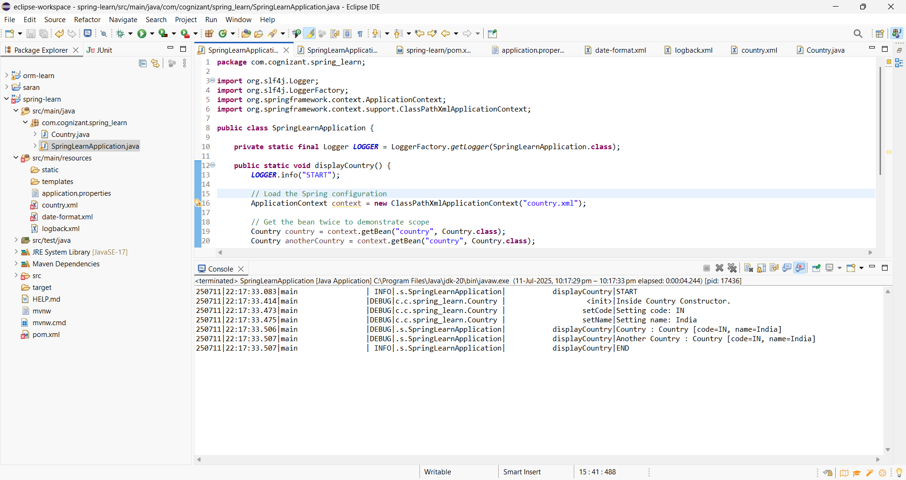

**Hands on 6**

**Spring Core – Load list of countries from Spring Configuration XML**Our main objective was to retrieve the list of four countries for the airlines website. Refer steps below to get this incorporated. 

* Create a separate bean for each of the four country in country.xml.
* Create an ArrayList of Country in country.xml.

**Program:**

**country.xml**

<?xml version="1.0" encoding="UTF-8"?>

<beans xmlns="http://www.springframework.org/schema/beans"

xmlns:xsi="http://www.w3.org/2001/XMLSchema-instance"

xsi:schemaLocation="http://www.springframework.org/schema/beans

https://www.springframework.org/schema/beans/spring-beans.xsd">

<!-- Country Beans -->

<bean id="in" class="com.cognizant.spring_learn.Country">

<property name="code" value="IN"/>

<property name="name" value="India"/>

</bean>

<bean id="us" class="com.cognizant.spring_learn.Country">

<property name="code" value="US"/>

<property name="name" value="United States"/>

</bean>

<bean id="de" class="com.cognizant.spring_learn.Country">

<property name="code" value="DE"/>

<property name="name" value="Germany"/>

</bean>

<bean id="jp" class="com.cognizant.spring_learn.Country">

<property name="code" value="JP"/>

<property name="name" value="Japan"/>

</bean>

<!-- List of Countries -->

<bean id="countryList" class="java.util.ArrayList">

<constructor-arg>

<list>

<ref bean="in"/>

<ref bean="us"/>

<ref bean="de"/>

<ref bean="jp"/>

</list>

</constructor-arg>

</bean>

</beans>

**logback.xml**

<configuration>

<appender name="STDOUT" class="ch.qos.logback.core.ConsoleAppender">

<encoder>

<pattern>%d{yyMMdd}|%d{HH:mm:ss.SSS}|%-20.20thread|%5p|%-25.25logger{25}|%25M|%m%n</pattern>

</encoder>

</appender>

<logger name="com.cognizant.spring_learn" level="DEBUG"/>

<root level="INFO">

<appender-ref ref="STDOUT"/>

</root>

</configuration>

**Country.java**

package com.cognizant.spring_learn;

import org.slf4j.Logger;

import org.slf4j.LoggerFactory;

public class Country {

private static final Logger *LOGGER* = LoggerFactory.*getLogger*(Country.class);

private String code;

private String name;

public Country() {

*LOGGER*.debug("Inside Country Constructor.");

}

public String getCode() {

*LOGGER*.debug("Getting code: {}", code);

return code;

}

public void setCode(String code) {

*LOGGER*.debug("Setting code: {}", code);

this.code = code;

}

public String getName() {

*LOGGER*.debug("Getting name: {}", name);

return name;

}

public void setName(String name) {

*LOGGER*.debug("Setting name: {}", name);

this.name = name;

}

@Override

public String toString() {

return "Country [code=" + code + ", name=" + name + "]";

}

}

**SpringLearnApplication.java**

package com.cognizant.spring_learn;

import java.util.ArrayList;

import java.util.List;

import org.slf4j.Logger;

import org.slf4j.LoggerFactory;

import org.springframework.context.ApplicationContext;

import org.springframework.context.support.ClassPathXmlApplicationContext;

public class SpringLearnApplication {

private static final Logger *LOGGER* = LoggerFactory.*getLogger*(SpringLearnApplication.class);

public static void displayCountries() {

*LOGGER*.info("START");

ApplicationContext context = new ClassPathXmlApplicationContext("country.xml");

List<Country> countryList = context.getBean("countryList", ArrayList.class);

*LOGGER*.debug("Country List: {}", countryList);

*LOGGER*.info("END");

}

public static void main(String[] args) {

*displayCountries*();

}

}

**Output:**

